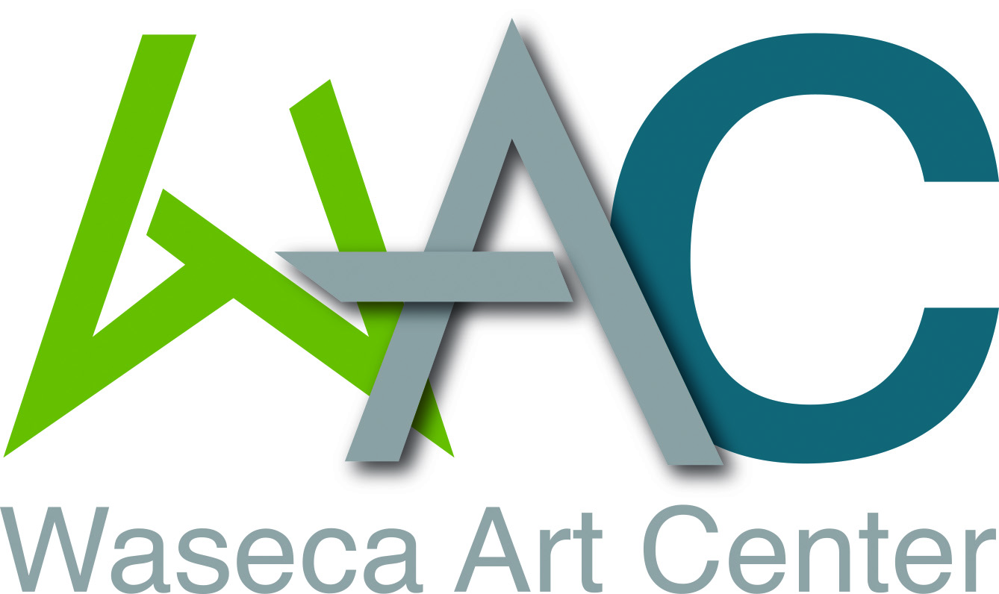
Address: 200 N State St, Waseca MN 56093
Phone: 507.835.1701
Email: info@wasecaartscouncil.org

Waseca Art Center - Student Mentorship Program
Artist Application
Please fill out the information below

Instructor Contact Information:
Name:
Address:
City: Sate: Zipcode:
Phone:
Email:

Terms:
- Applicant must be 21 years of age or older and reside in the Southern Minnesota Region.
- Applicant must be available at least 4 times per semester to meet with students for:
  - One-on-one time with student artist prior to an assignment in order to discuss and work through concepts.
  - One-on-one time with student artist while the they are implementing their project to discuss and enhance technique
  - One-on-one time with students while they are finishing their project to discuss changes, challenges that have occured
  - One-on-one final review of the project to discuss display options and next steps to encourage students to showcase their work to the public in our community

Instructor’s Professional Biography:

Instructor’s Additional Education, Certifications, and Qualifications:

Please include a small portfolio of images from your previous work (i.e. paintings, sculpture, fabrication)

Please Provide TWO Professional References:

Have you taught with WAC before? Yes No
Prefered Mentorship Medium:

Desired Location/s: Waseca Jr./Sr. High School
Waseca Alternative Learning Center
Owatonna Choice Technical Academy
NRHEG Schools
Prefered Class Days:
Monday Tuesday Wednesday Thursday Friday
Prefered Class Times:
Morning Afternoon

Please submit application by email to info@wasecaartscouncil.org or by dropping it off at the Waseca Art Center located at 200 N State St, Waseca MN 5609, open Tuesday-Friday 11am-5pm and Saturday 10am-1pm.
Thank you for your interest in teaching with the Waseca Art Center.

